1
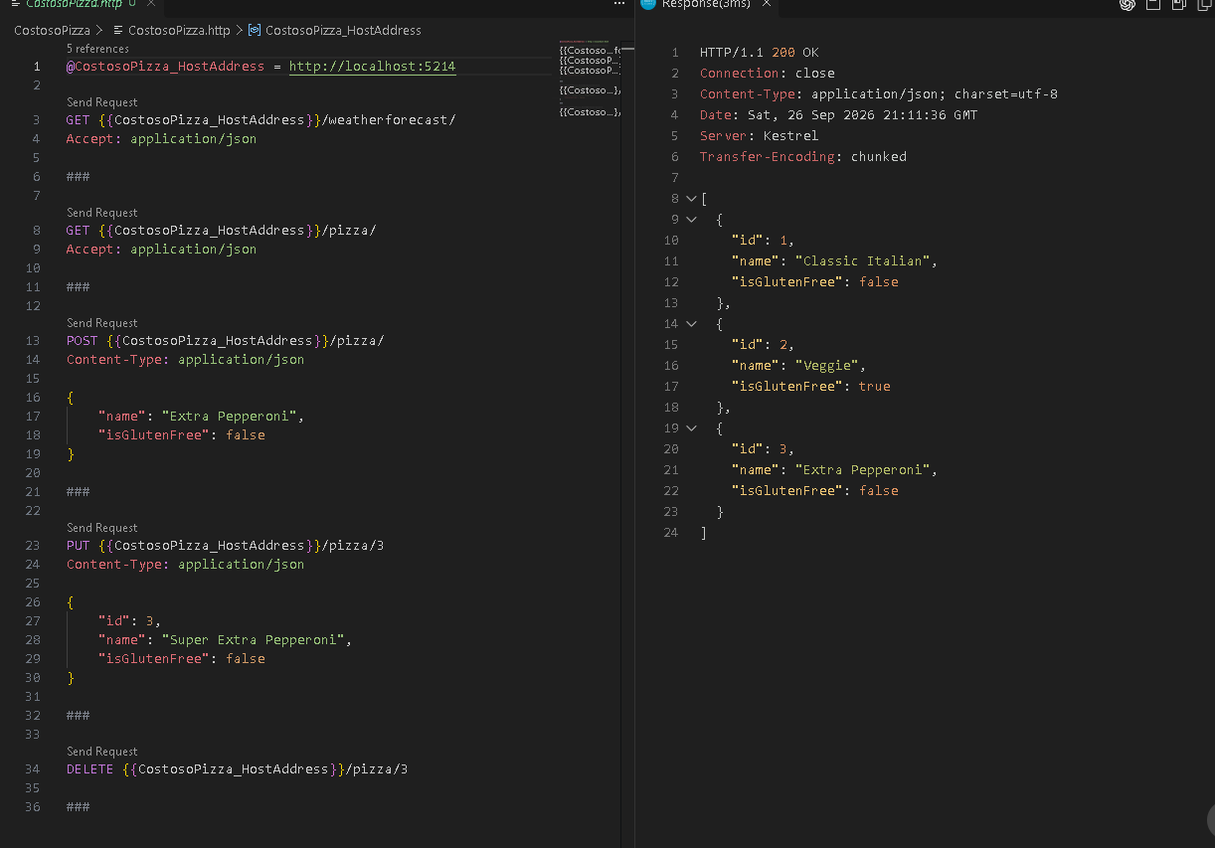

//Generate the final report
GenerateReport(salesFiles, salesTotalDir, salesTotal);

void GenerateReport(IEnumerable<string> salesFiles, string salesTotalDir, double salesTotal)
{
//creates StringBuilder to buuild the report line by line
StringBuilder report = new StringBuilder();

report.AppendLine("Sales Summary Report");
report.AppendLine("====================");
report.AppendLine("");

report.AppendLine($"Total Sales: {salesTotal:C}");
report.AppendLine("");

report.AppendLine("Details:");

//loop each sales files found
foreach (var file in salesFiles)
{
// Read the contents of the current JSON file
string salesJson = File.ReadAllText(file);

//get only the folder and the file name
var folder = Path.GetFileName(Path.GetDirectoryName(file));
var filename = Path.GetFileName(file);

//chheck the file if is salestotal.json // I did this because I didnt know if we supouse to take both files or just the sales.json
if (filename == "salestotals.json")
{
SalesData? data =
JsonConvert.DeserializeObject<SalesData?>(salesJson);

double fileOverallTotal = data?.OverallTotal ?? 0;

report.AppendLine(
$"{folder}/{filename}: - Overall Total: {fileOverallTotal:C}"
);
}
else
{
SalesData? data =
JsonConvert.DeserializeObject<SalesData?>(salesJson);

double fileTotal = data?.Total ?? 0;

report.AppendLine(
$"{folder}/{filename}: - Total: {fileTotal:C}"
);
}
}

//creates the full path for the report file
var reportFilePath = Path.Combine(salesTotalDir, "SalesReport.txt");
//Write the report to the file
File.WriteAllText(reportFilePath, report.ToString());

}

//added the overallTotal to show in the report
record SalesData(double Total, double OverallTotal);

